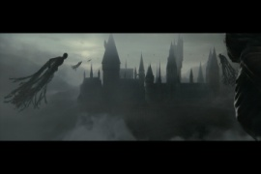 | HARRY POTTER and the DEATHLY HALLOWS: Part 2 (2011) - Composited  multi-pass 3D smoke, mist, Dementors and BG. Created timing of reveal as well as transition from provided WB logo.
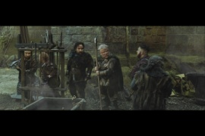 | SNOW WHITE and the HUNTSMAN (2012) - Warped full size actors to “Dwarf” size with multiple 2D techniques. Extracted green screen mattes and composited multiple elements.
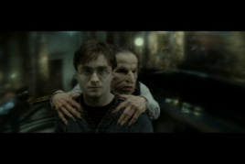 | HARRY POTTER and the DEATHLY HALLOWS: Part 2 (2011) - Created invisibility cloak look using 2D and 3D FX passes. Created transition effect from interior to exterior of cloak. Extracted green screen mattes and composited foreground characters.
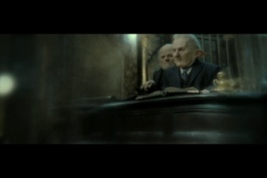 | HARRY POTTER and the DEATHLY HALLOWS: Part 2 (2011) - Created invisibility cloak look using 2D and 3D FX passes.
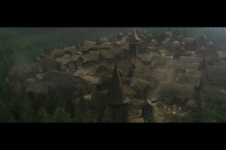 | RED RIDING HOOD (2011) – Transitioned from helicopter plate to studio set of village. Composited multi-pass 3D village and 3D foreground trees. Projected background matte painting on multiple 3D cards as well as created 3D “card” forest in Nuke. Rotoscoped foreground live action trees. Added multiple 2D mist elements, light rays, lens flare and other atmospherics.
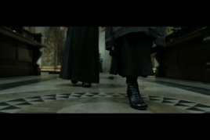 | HARRY POTTER and the DEATHLY HALLOWS: Part 2 (2011) - Created invisibility cloak look using 2D elements. Extracted green screen mattes and composited feet to match practical plate.
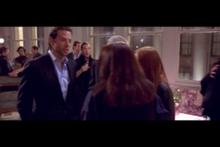 | LIMITLESS (2011) - Composited crowd duplication with multiple motion control passes
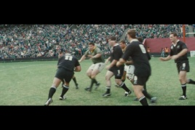 | INVICTUS (2009) - Composited CG Stadium and Crowd multi-pass renders, removed camera crew from rugby field
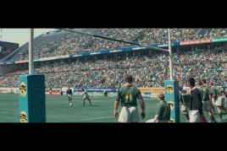 | INVICTUS (2009) - Composited CG Stadium and Crowd multi-pass renders, rotoscoped and color corrected players Jerseys
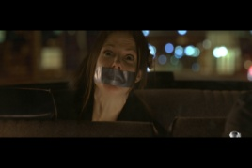 | RED (2010) – Extracted green screen matte and composited background driving plate and added foreground reflections and flares.
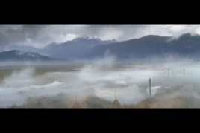 | RED RIDING HOOD (2011) - Projected matte painting onto multiple 3D cards and ground plane with 3D camera. Added multiple 2D and 3D elements and an overall color correct.
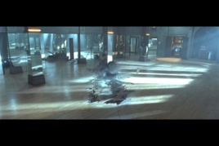 | TWILIGHT (2008) – Wire and Crew removal from multiple mirrors

